Git and Git Hub Challenges Task

- Resolve Merge Conflicts
Create a merge conflict intentionally (two users editing the same line).
Resolve the conflict and push the changes

- I created a zero-byte file using the touch command and added it to the staging area using git add <filename>. Then I committed the changes with git commit -m. After that, I switched to another branch using git checkout and repeated the same process with the same file name. When I tried to merge the two branches, I encountered a merge conflict because both branches had a file with the same name. I opened the file, kept the content I wanted, removed the unwanted content, and after saving the file, Git automatically merged it and the merge conflict was resolved.

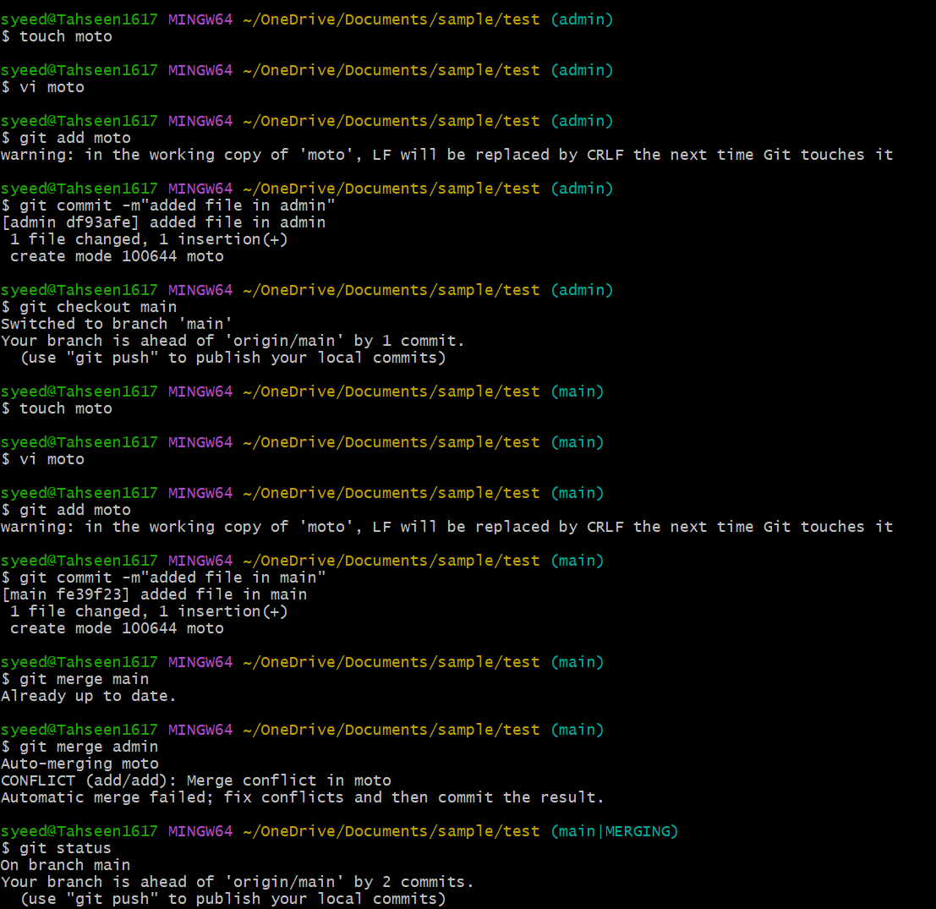

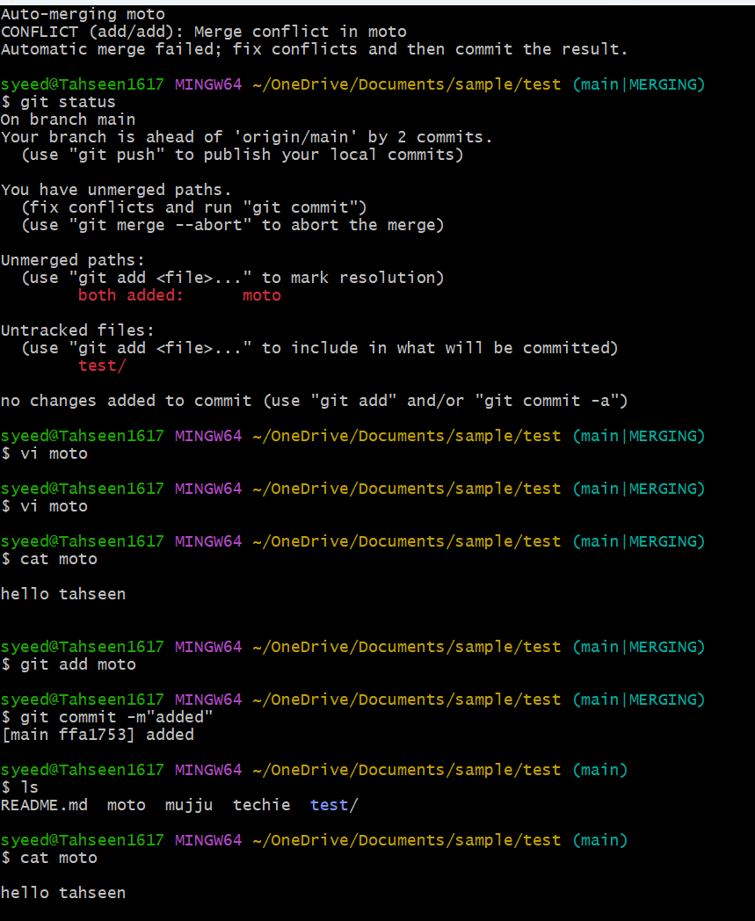

- Recover Deleted Branch
Delete a local branch and then recover it using the reflog.
  - Created a new branch in local by using git branch branch name command then committed a file in the branch.

  - Then deleted the branch by using git branch -d branch name and I got a commit by using git checkout -b restored branch and commit id I was able to get the branch restored.

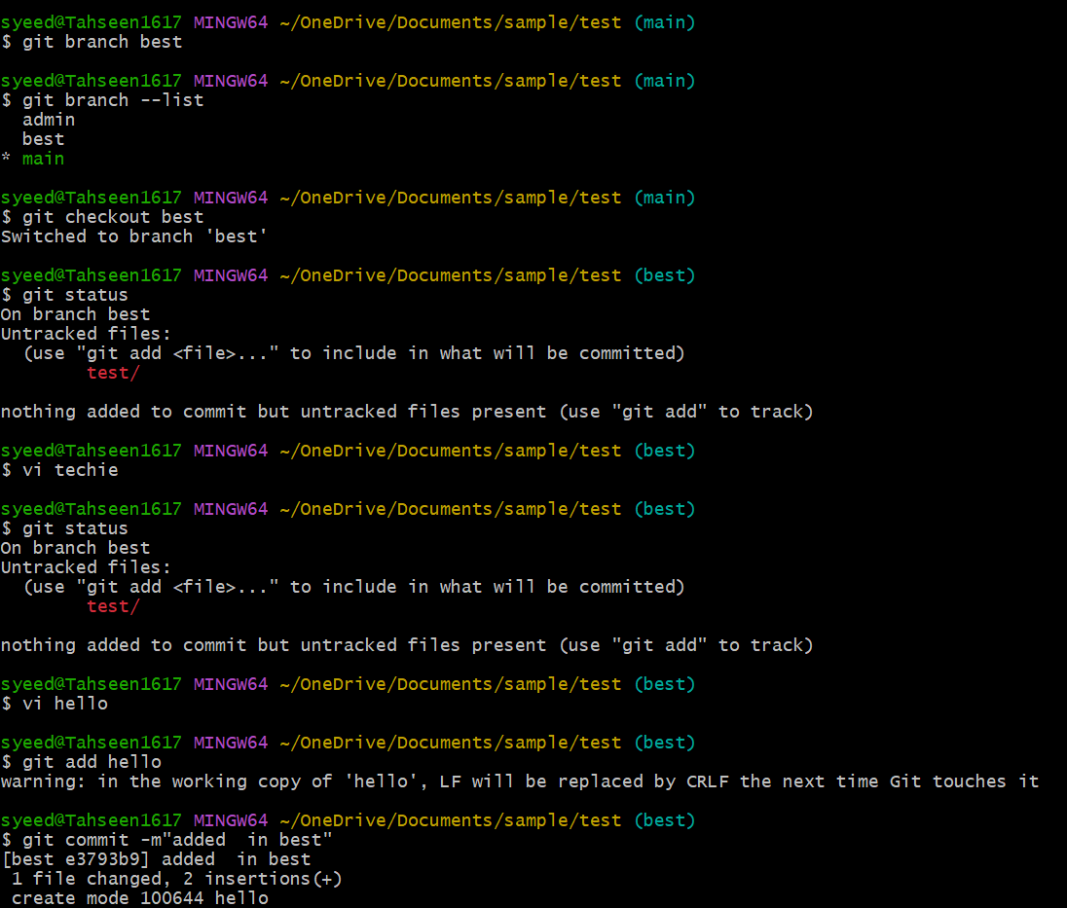

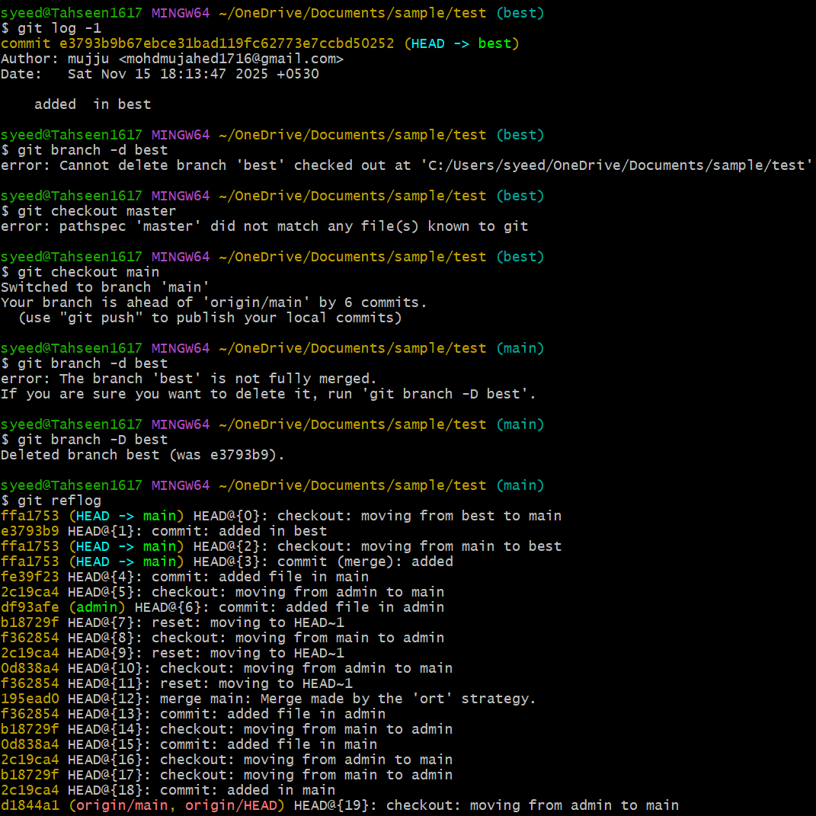

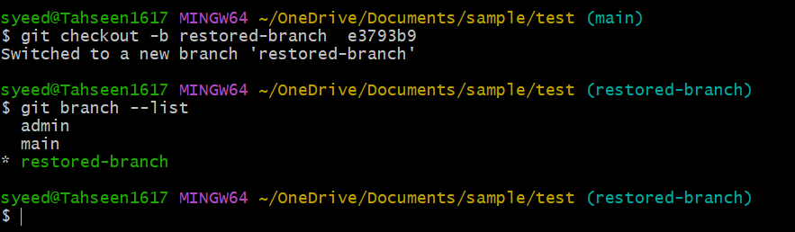

- Undo Wrong Push
Push a wrong commit to GitHub, then undo it without losing history
- I added a file, wrote a commit message, and pushed it to the central repository. Then I used git revert <commit-id> to revert the changes.

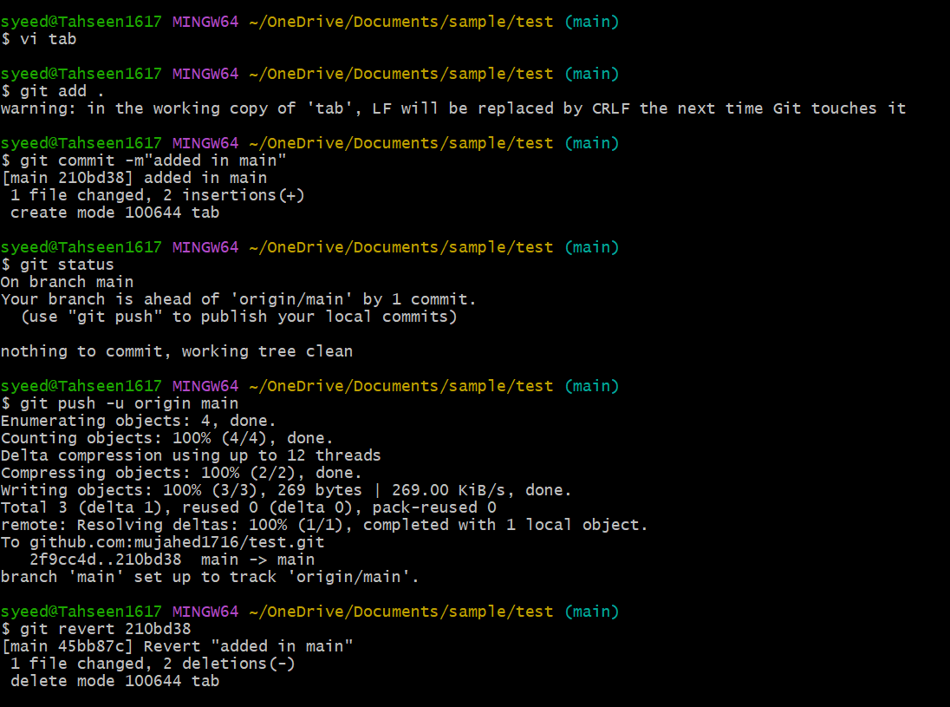

- Amend a Commit
Make a commit, then add a missing file to it using git commit --amend.
- Here, I used the git commit --amend command to modify the commit message.

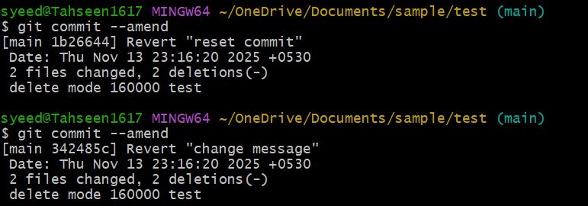

- Cherry-pick a Commit
Take a specific commit from one branch and apply it to another branch.

- I checked the last four commits using the git log -4 command. After that, I switched to another branch using git checkout. Then I used git cherry-pick <commit-id> to apply that specific commit to the new branch
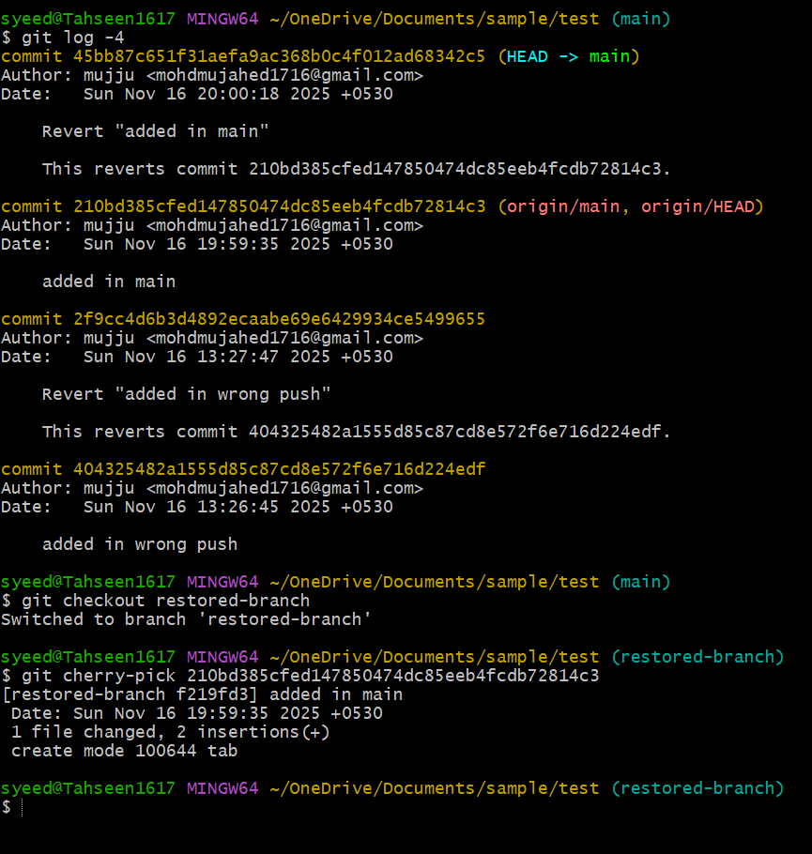

- Interactive Rebase
- git log -4 was used to view the last four commits.
- git rebase -i HEAD~1 is used to merge all commits into a single commit.
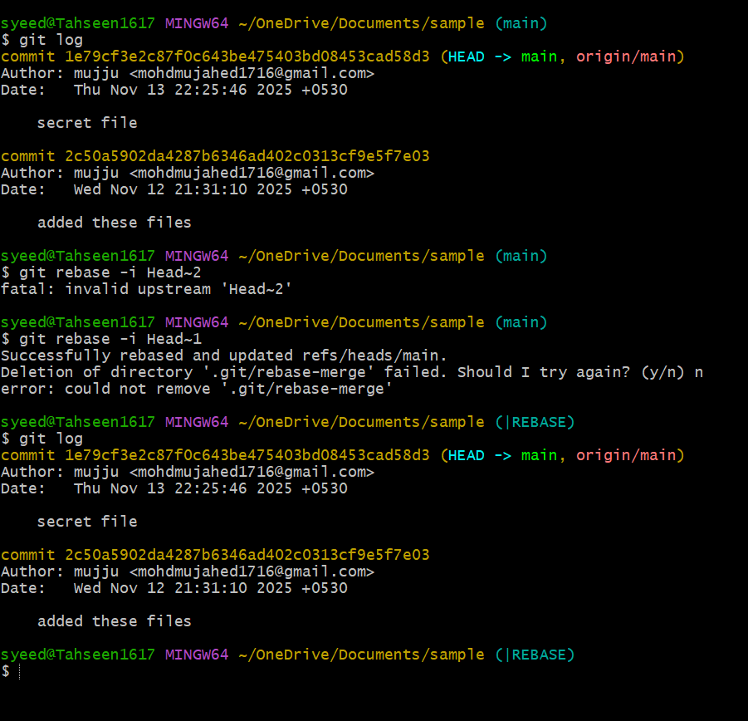

- Tagging & Release
- I created a tag using git tag v1.0.0 and pushed it. Then I deleted the tag with git tag -d v1.0.0. After that, I used git log -4 to view recent commits, copied the commit ID, and restored the tag using git tag v1.0.0 <commit-id>. Finally, I verified the tag by running git tag.
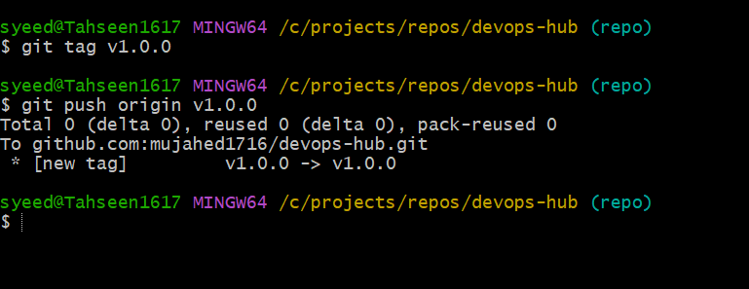
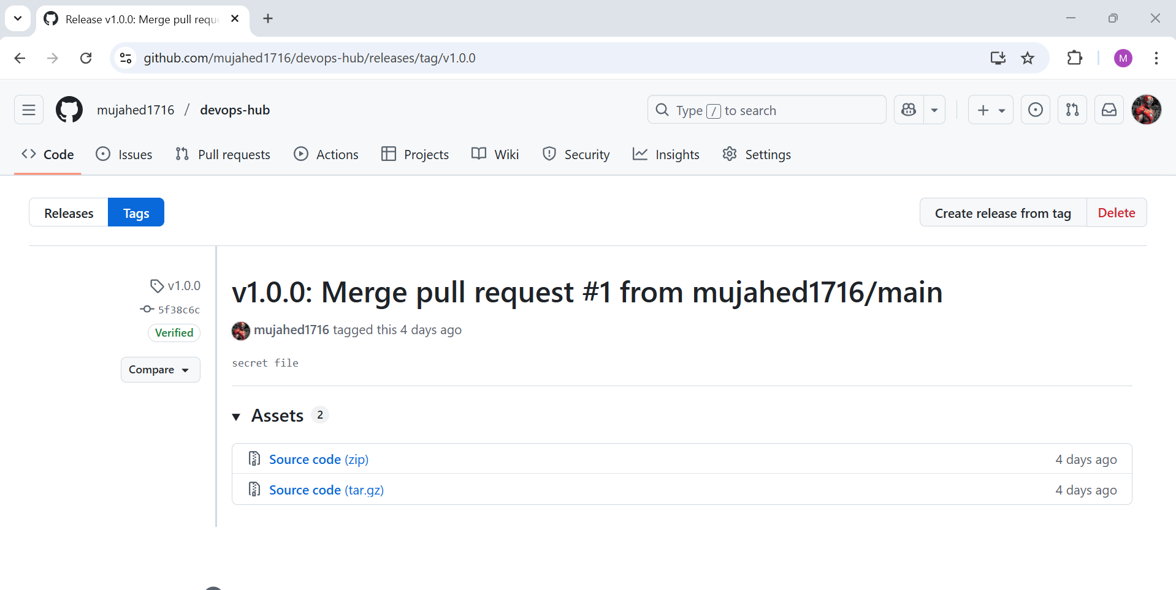
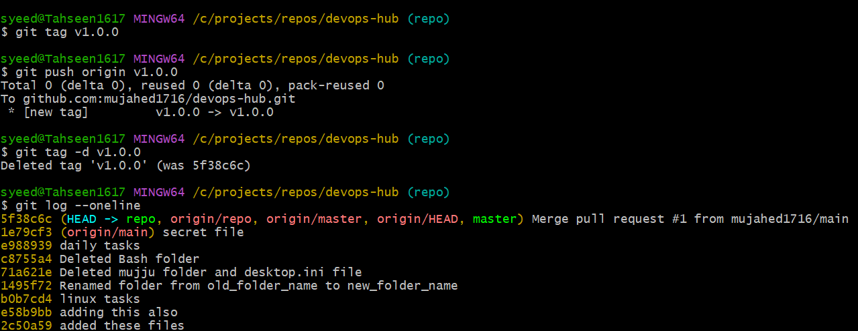
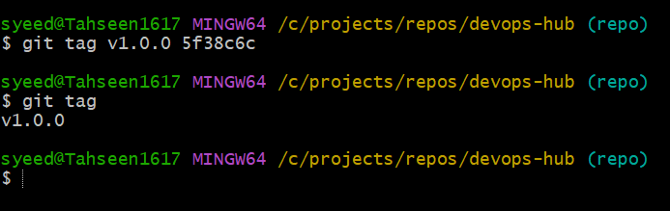

8. Clone with Sparse Checkout

- This clones the repository without checking out any files git clone --no-checkout git@github.com:mujahed1716/devops-hub.git

git sparse-checkout init
- This enables sparse checkout mode.
- It tells Git that you want to download only specific folders/files, not the whole repository.

git sparse-checkout set devops-hub
- This command selects which directory you want Git to check out
- Here, I selected the folder named devops-hub.
- Git now downloads only that folder from the repository instead of the entire repo
- ls -R . used to verify that sparse checkout worked successfully
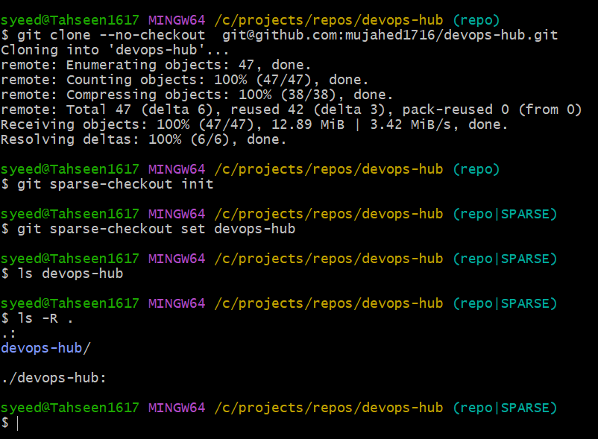

9.Reset vs Revert Challenge
- git log -4 — You checked the last four commits to see the commit history.
- git revert <commit-id> — You reverted the selected commit, and Git created a new commit that undid the changes from that commit.
- Git showed that a file was added/changed as part of the revert.
- git reset --hard — You forced your working directory to match the latest revert commit.
- After this, your repo moved to the new revert commit and all changes were refreshed to match it.

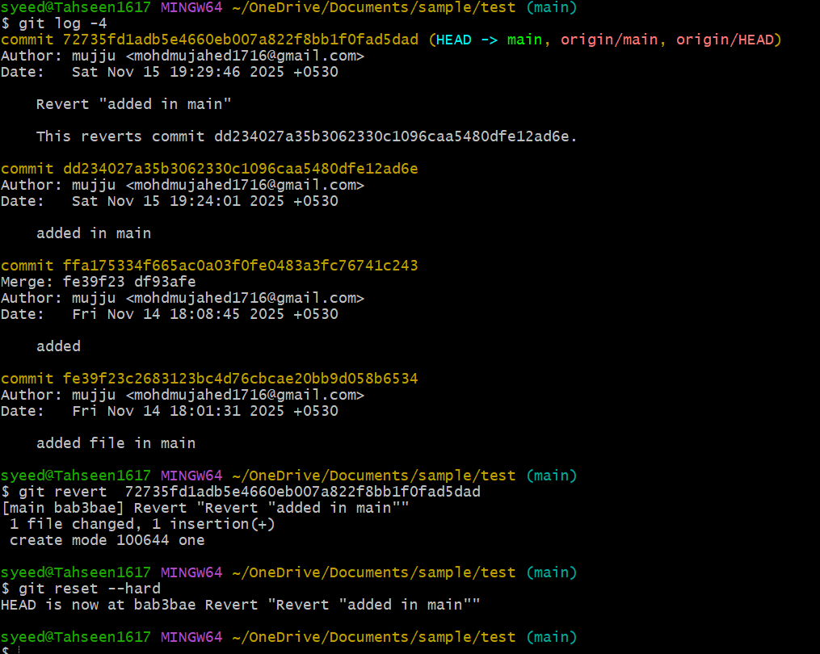

10. Detached HEAD Challenge
git log --oneline
- You checked the commit history in short form.
git checkout <commit-id>
- switched to an old commit (e988939) and entered detached HEAD mode.
Git showed a message saying you are in detached HEAD (meaning you are not on any branch).
git checkout -b tasks-before-deletion
- created a new branch from that old commit.
git branch --list
- listed all branches to confirm the new branch was created.

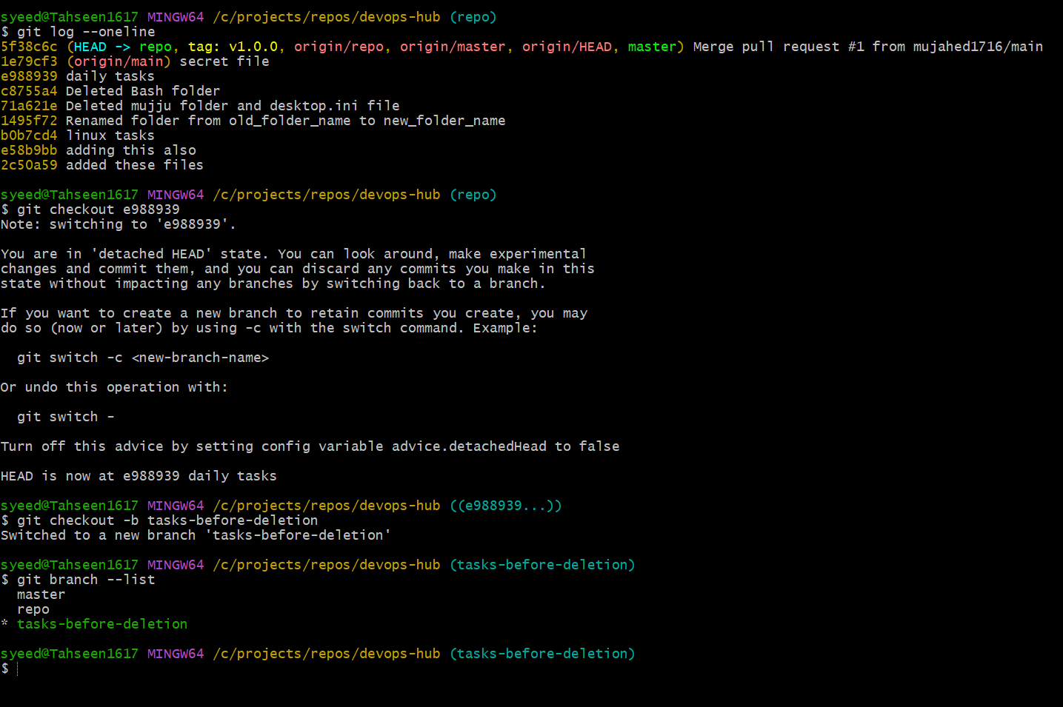

12. Squash Merge vs Rebase Merge
Squash Merge
- Combined all commits from repo into one commit
- Added to master
- Pushed to GitHub
Rebase
- Rebasing repo on master removed duplicate commits
- After rebase, repo matched master
- Merging repo → master became fast-forward
- Final push updated master

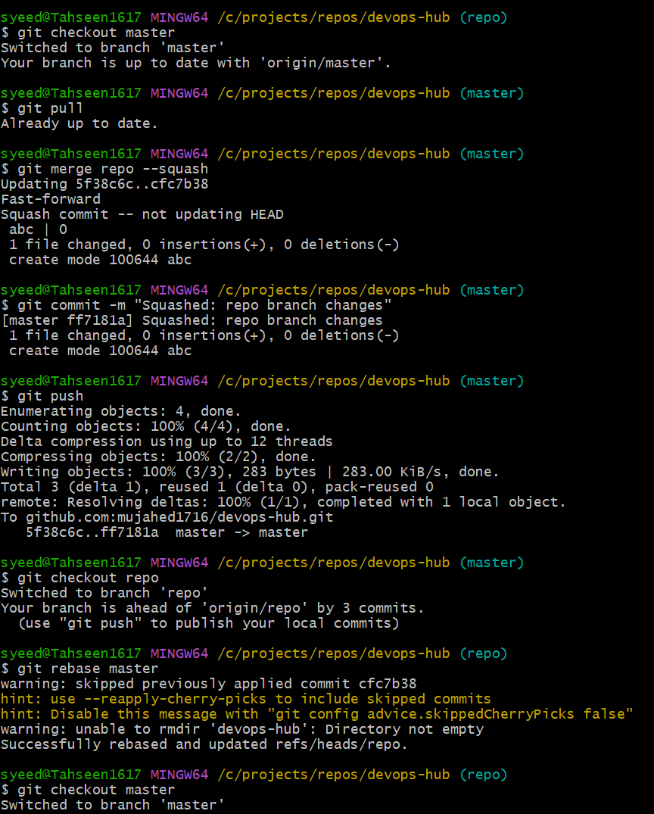

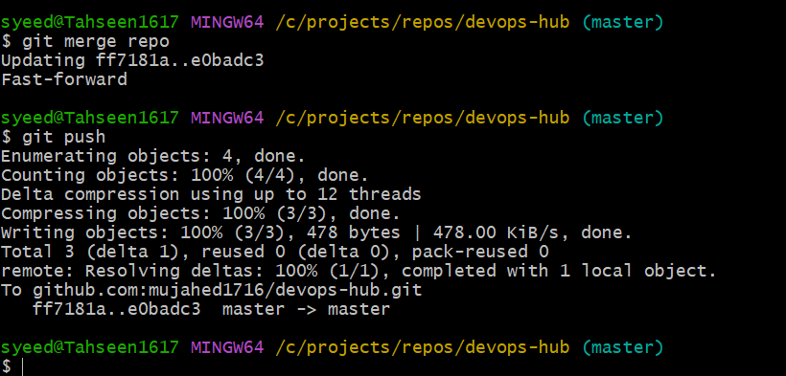

13. Fork & Pull Request Workflow
- Using fork I have cloned a repository into my local machine and before running git commands, you must be inside the project folder.
- By doing ls I have seen the files I have made a change in readme.md file and added into tracking area and commited with a commit message then pushed into central repository.
- created a PR titled “pr added to repo” from your forked repo branch to the original repository’s main branch.
- On GitHub, you clicked Merge pull request → Confirm merge

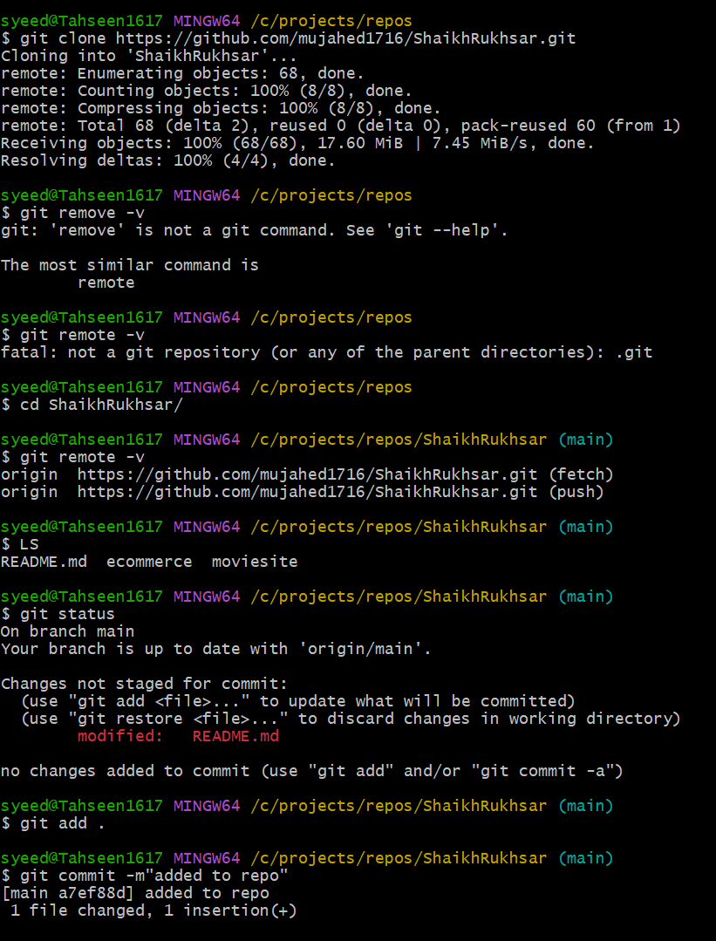

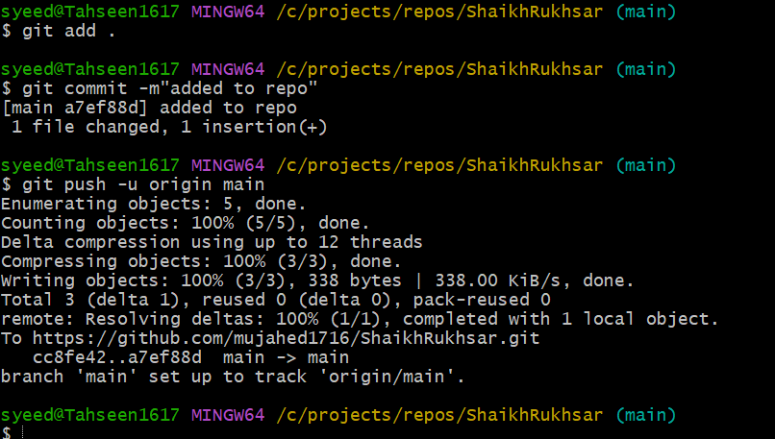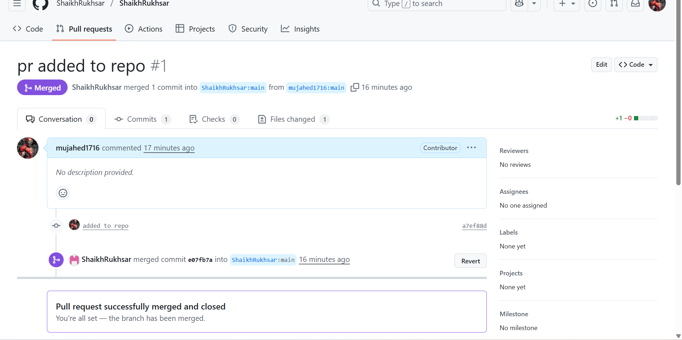

14. Recover Lost Commit
Commit something, reset hard, and then recover it using git reflog.
- Created a commit
Deleted the commit using reset --hard
Found the commit in git reflog
Restored it using reset --hard <commit-id>
Verified recovery using git log
